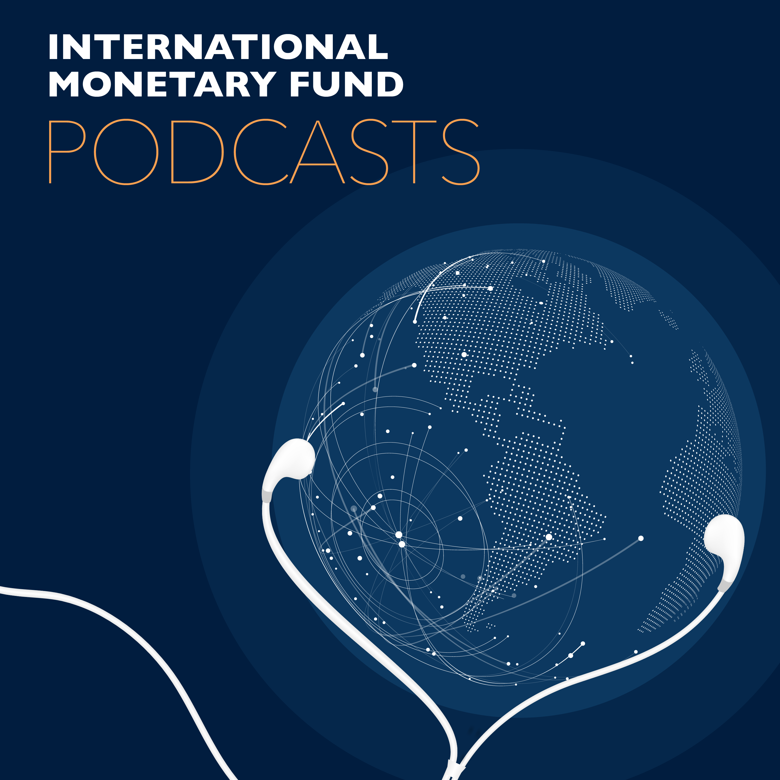
Transcript of IMF podcast:
Martin Muhleisen: Mitigating Economic Fallout of Coronavirus
Martin Muhleisen:
How can a country sustain the economy during those weeks and months where people have to be cautious in being in close contact?
Bruce Edwards:
In this program, mitigating the economic fallout of the Corona virus.
Martin Muhleisen:
Markets have already reacted by very sharp capital outflows from emerging markets, and that will be a challenge that will be very difficult to address.
My name is Martin Muhleisen, I'm an economist at the IMF. I'm working in the strategy policy and review department. We're very much engaged at the moment in the efforts of the IMF to combat the ongoing crisis. There are a lot of tools that the IMF have. And the experience that my colleagues and I have from various crises, for example, during the Euro area or the global financial crisis, will come to bear in this respect.
Bruce Edwards:
Welcome to this podcast produced by the International Monetary Fund, I'm Bruce Edwards.
The coronavirus has wreaked havoc on just about every aspect of life around the world. The limited human contact required to contain the spread of the virus is hindering economic activity, and in turn putting enormous pressure on the global economy. Martin Muhleisen says, even if an individual country is fortunate enough to escape widespread viral contagion, it's likely it will still feel the economic fallout.
Bruce Edwards:
At what point does a public health crisis turn into an economic crisis? I mean, how can a health issue of this scale impact economies?
Martin Muhleisen:
It is a very unusual crisis. So clearly it started with a virus, with the health concerns that people have. And this has created huge uncertainty, because even if it's not a very deadly virus, it is one that spreads very easily. And the health concerns are big enough that if the virus is not contained health systems could get overburdened, and then the human loss and the suffering that would be caused would be quite large. And we've seen that in some countries already.
Martin Muhleisen:
What it means for the economy is that it has a big demand effect, because people withdraw. People have to be isolated in order to not get affected by the virus. And that means that many economic sectors that are connected to people being out and interacting with other people, traveling, consuming services, and the like are receiving a big hit. And more generally economic activity is slowing because people also don't want to go shopping, for example.
Martin Muhleisen:
It is also of course a supply shock, in the sense that people can't go to work as they used to do. They need to take precautions. Some countries have to cease production, or I mean not fully but to a big degree. And that means, due to the interconnected nature of the global economy, that there are shocks to the supply lines. And that has also ripple effects.
Martin Muhleisen:
So what all means is that economic activity is really slowing down sharply. And financial markets then react to that situation. Stock markets are the most well known kind of markets. People look how they decline. And it's due to the fact that corporates need to revise their profit expectations. They have difficulties in making these profits. In some cases they have difficulties paying back loans or credit. The longer the crisis lasts, the longer the shocks, in fact, the bigger the difficulties for many companies. And of course stock markets react to that. And also, companies will have to draw down credit lines from banks.
Martin Muhleisen:
And so we have a situation now where the health shock translates into in these kind of supply and demand shocks, and the ripple effects to the financial sector and are quite severe. Luckily I would think that financial institutions more broadly are in a better shape than, say for example, before the global financial crisis. A lot of work has gone in to making sure that they were capitalized, and that they are resilient to different types of shocks.
Martin Muhleisen:
Also we've gone into this crisis, although the economy has since slowed down a little, with a very long expansion and high employment rates. And you would hope that that creates some buffers against the very weak activity for the next months. So, in that sense the crisis has come at a time where hopefully we are prepared for this kind of shock and where we can deal with it. Although the effects would probably be quite severe.
Bruce Edwards:
So, while health professionals around the world are scrambling to contain the health risks of this pandemic, what will it take, do you think, to contain the economic repercussions?
Martin Muhleisen:
Yeah. I think you mentioned the core of the issue, which is really health professionals and health organizations, health ministries, governments. I think the core of fighting the crisis has to be in helping to limit the spread of the virus. And also to do it in a way that provides, at some point, confidence that this will be a temporary shock, and that the effects will not last for many months.
Martin Muhleisen:
In some cases, of course it may be necessary, and governments will know that isolation has to be kept up for some time. But the better organized and the more coordinated the health responses to this crisis, the more quickly it may be possible that confidence returns.
Martin Muhleisen:
On the economic side, banks and governments have already undertaken quite unprecedented measures to both provide liquidity to the markets, make sure that markets continue to function. There's a need to provide support, especially to those sectors that are hardest hit. And some governments also are undertaking enormous efforts to also support citizens directly, as they face weeks without paychecks, for example. So that is really important.
Martin Muhleisen:
The Fund would recommend that all of this is done in a way that's ideally coordinated to amplify the actions of each individual government or central bank. That there's also a strong communication that helps markets, individuals, companies to maintain confidence. And we've already seen a lot, and maybe more will be needed, but it's best if this is all done, ideally, in a way that shows that the global community is united in the fight against this challenge.
Martin Muhleisen:
The IMF also has a role to play, of course. We have several instruments, such as rapid financing arrangements. We have IMF programs. We are also looking into how we can help the poorest countries, through some kind of grants provided by our members that will facilitates the debt repayments to the IMF. So we have a role to play. We are in very close touch with our member countries, and we've already received a lot of requests for help that we can help proceed as speedily as possible.
Bruce Edwards:
So is this crisis, do you think, proving harder for emerging and developing economies to handle, as compared to you know, other crises that they've suffered in the past?
Martin Muhleisen:
They are facing quite a challenge, because the same measures that will lead to hopefully a decline in the spread of the virus in advanced economies will of course also have to be taken by all the other countries. There is no other way probably to fight the crisis than to isolate people somewhat from each other and limit the potential for contagion.
Martin Muhleisen:
It also I think presents a big challenge for health systems in emerging and developing countries. And it's important not to treat everybody alike, of course. There are some countries that are in a relatively good position, but other countries are not. And for them the health shock will be a very difficult one to master. They need a lot of help from the international community.
Martin Muhleisen:
But then, again, on top of that comes to the same question that other countries are also facing. How can a country sustain the economy during those weeks and months where people have to be cautious in being in close contact? Markets have already been reacting by very sharp capital outflows from emerging markets. And that that will be a challenge that will be very difficult to address. And again, the IMF can help.
Martin Muhleisen:
There's also the question of commodity prices. That is really important for many countries. The sharp drop in commodity prices is a challenge for those who rely on revenues from commodity exports. It is a boon to other countries that are commodity importers. So again, it's not the same for every country, but for these countries that that face a loss of revenue that's quite sharp and potentially somewhat long lasting, that will just add to the complications from the situation that they're already facing.
Bruce Edwards:
So it seems every few months now there's another natural disaster that threatens to wipe out critical infrastructure, and puts enormous pressure on economies. What does this increase in frequency and intensity of natural disasters mean for the Fund? I mean, in terms of maintaining financial stability, which is essentially its mandate.
Martin Muhleisen:
I would still distinguish the current crisis from crises that we have also seen on the natural disaster side. This is already a very unique challenge. We did have, of course, different virus scares over the last decades. And we may face them again in the future.
Martin Muhleisen:
We know that mobility and social interaction around the world provide some environment. I would still separate out natural disasters. These are of course more localized. They hit regions or particular countries. The overall climate change is a global phenomenon, but at least at the moment, what we see is manifestations mostly in the somewhat limited area.
Martin Muhleisen:
Having said that, we have already responded to climate disasters in the past. We do have facilities, lending facilities, that are geared toward that type of economic hit. For smaller countries this is a big challenge, and we're helping on working on the finances, both before a disaster to build up resilience, and if it happens then we can help countries to rebuild quickly.
Martin Muhleisen:
We're working very closely here with other institutions such as the World Bank or development banks, that also have specific tools to help countries. That is very much focused on specific countries that are more prone to these disasters.
Martin Muhleisen:
More broadly, going forward, disasters pose a risk increasingly also to economies that otherwise have the means to resist. They pose a risk to financial systems, in part because if there's a repricing of assets that are linked to the carbon economy, for example, in the case of introduction of carbon taxes, that it becomes less valuable, then a lot of financial agents and institutions that are exposed to these assets, they may take quite a hit. And so that then creates issues for financial stability, possibly. But this is perhaps a less fast-moving issue and can be addressed by proper planning and through the right economic incentives.
Martin Muhleisen:
But in any case, the fund had to adjust quite a bit it's thinking. We're no longer in the world of simple, quote unquote, capital account prices. The world has become much more complex. And we've been thinking about climate, and we've been thinking about disease outbreaks, we've been thinking about issues such as cyber risks, or new financial technologies, and the challenges they bring.
Martin Muhleisen:
In the end, our mandate is to help our member countries maintain economic and financial stability. And so we're looking at many different areas.
Bruce Edwards:
So are you confident that the world will actually emerge from this crisis better prepared for the next one?
Martin Muhleisen:
I hope that we will get well through that crisis. I think the international community has the tools, countries have the tools, to ensure that we to emerge from it. There will be a recovery. It is a temporary crisis. And yes, also in a sense every crisis is a chance to learn. What I personally, and what my colleagues and our institution is experiencing is a very strong sense of global cooperation.
Martin Muhleisen:
So, as you can imagine, we've been in many conference calls, not meetings anymore, we're all working from home. But we've been in many, many conference calls among global institutions, with countries, with groups of country ministers, governors, officials joining in to see how we can all cooperate in this crisis.
Martin Muhleisen:
And I think as we come out of it, it will be seen that the value of global cooperation is really large, and can help us minimize the impact of crises. So I would expect that this can be a lesson from that one.
Martin Muhleisen:
We also, I think, appreciate very much the work that has done over the last decade in boosting the resilience of the financial sector. This will be a critical factor during this crisis. And one lesson, probably, that we also are going to be taking away from is that it's important for governments, corporates to go into crises when the times are good. To go into crises with sufficient buffers. And so the issue of high debt is something that we're going to need to rethink as we come out of the crisis. It's important that countries act responsibly, and that we keep room to respond if there is indeed a need for a public policy response to the degree that is happening at the moment.
Bruce Edwards:
Thanks so much, Martin. I appreciate it.
Martin Muhleisen:
Thank you, you're welcome.
Bruce Edwards:
Martin Muhleisen is director of the IMF's Strategy, Policy, and Review department. Go to imf.org to find out more about how the IMF and its global partners are responding to the coronavirus pandemic.
Bruce Edwards:
Look for other IMF podcasts, wherever you get your podcasts, subscribe if you like what you're hearing, and follow us on Twitter @IMF_podcast. Thanks for listening.

