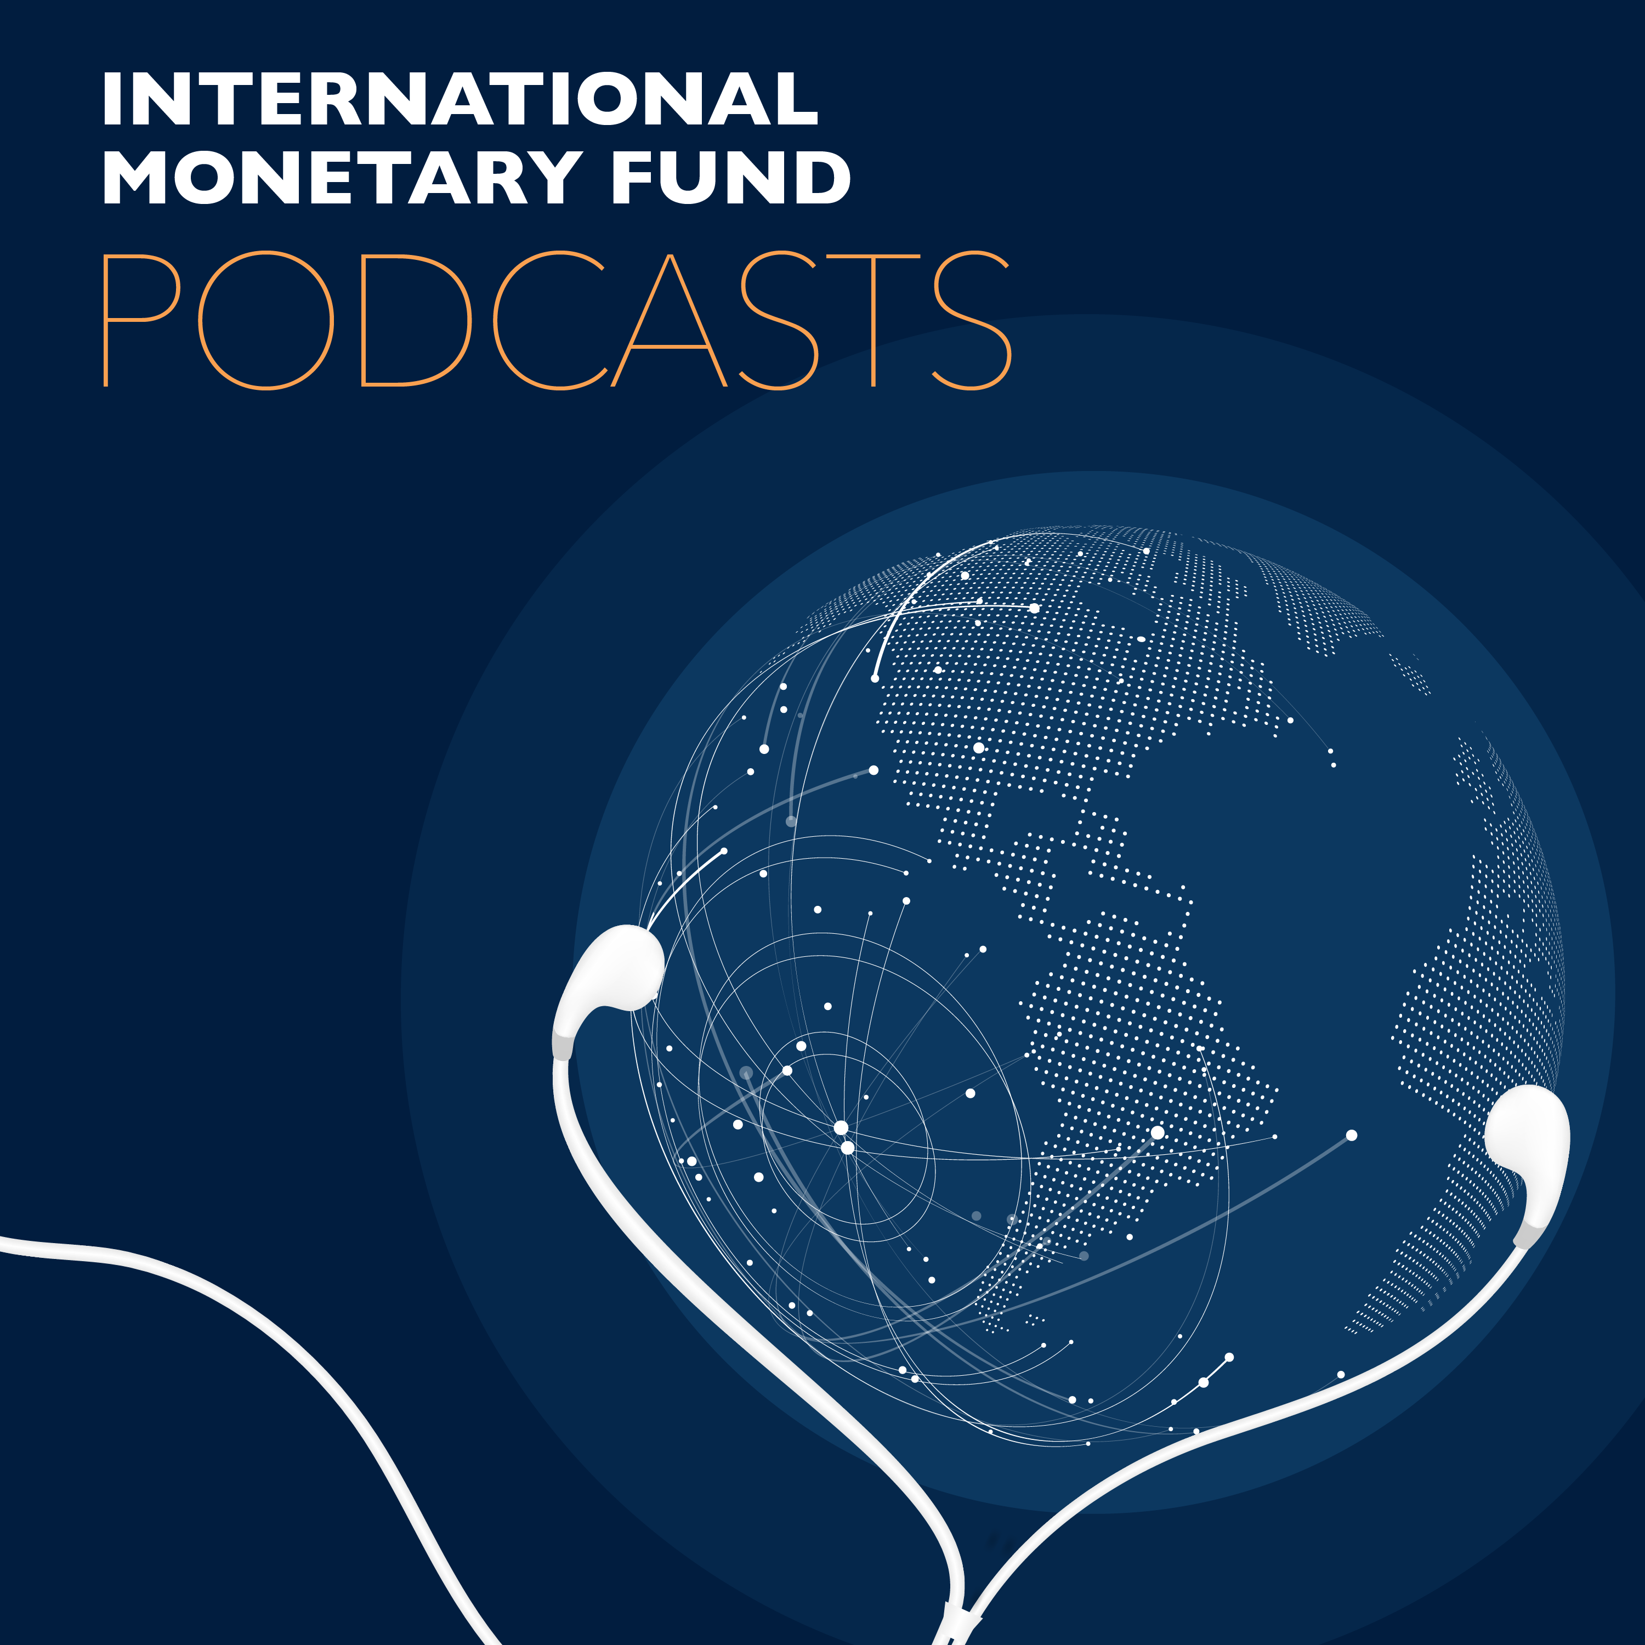
Transcript of IMF podcast:
Jihad Azour: Middle East, Central Asia Face Perfect Storm Amid COVID-19
Jihad Azour:
For the region. This is a dual reinforcing shock. It's a perfect storm.
Bruce Edwards:
In this program, the weight of COVID-19 on the economies of the Middle East and Central Asia, especially on the regions fragile and conflict-torn states.
Jihad Azour:
I think it's very important to recognize that this crisis will hit more low income countries, developing countries than the rest of the world.
Jihad Azour:
I'm Jihad Azour, Director for Middle East and Central Asia Department at the International Monetary Fund.
Bruce Edwards:
And welcome to this podcast produced by the IMF. I'm Bruce Edwards. No region has been spared the economic devastation of the coronavirus pandemic and with the high level of oil dependency and informality of many countries in the Middle East and Central Asia, Jihad Azour says the economic impact of COVID-19 has been dramatic. Azour heads the IMF's Middle East and Central Asia department, which has just published the region's economic outlook that shows formidable challenges in the face of the pandemic.
Bruce Edwards:
So what is it about the nature of this crisis that makes it harder for countries to deal with?
Jihad Azour:
This crisis is like no other one before. It's a double shock that is reinforcing itself. Where the spreading of the coronavirus and its impact on the economy, as well as also the oil shock, with the drop in demand and then the sudden decline in oil prices. All countries in the region were affected by this crisis and most of them have been trying to cope with the COVID-19 shock by introducing a certain number of measures to protect life and livelihoods and also to protect certain sectors in the economy. However, if we compare to the last hundred years, this is one of the most challenging moments in economic history for both Central Asia Caucuses as well as also Middle East and North African countries.
Bruce Edwards:
And so, what has been the impact on the economies of these necessary containment measures?
Jihad Azour:
Well the containment measures added to the previous shocks, has led gradually to shut down the economy. And this had a big impact on sectors that are job-rich like tourism, trade, as well as also other important sectors on the service side, which has complicated the management of the crisis, especially for countries where the level of informality is high.
Bruce Edwards:
And so the oil sector is a lifeline for many countries in the region. Will these countries be able to cope with this dramatic drop in oil prices that we're seeing?
Jihad Azour:
Well, indeed the oil sector is important for the old producing countries, but not only for them, also for the oil importing ones. The oil exporting ones will face the impact of the shock on their revenues as well as also on their fiscal situation. Countries who have already buffers, they can use them to mitigate some of the repercussions of the shock. Others have less buffers and therefore for them the economic management is going to be more complicated, but in addition to the oil exporting, the oil importing countries given the level of remittances, capital flows and investment coming from the oil producers, they will be also indirectly facing the impact of the drop in oil price.
Bruce Edwards:
And there are longstanding conflicts in the region that have resulted in masses of people on the move. Do you worry that this will further complicate the containment of the virus and perhaps even extend the economic fallout?
Jihad Azour:
Of course this is an additional complexity, especially given the limited infrastructure and the quality of health and healthcare protection in those countries affected by conflict or countries who are hosting a large number of refugees. This adds into the complexity of managing a crisis like that. And this is also something that would require special attention, especially for countries where the level of fragility is already high.
Bruce Edwards:
And many countries have also suffered huge outflows of investment capital. What is the impact of that? And do you believe that investors will return to the region once this pandemic subsides?
Jihad Azour:
Countries of the region are active and the international capital markets are among the most active in the EM group, and therefore the sudden outflow of capital that we saw in the last few weeks affected them equally- or a bit less than what has happened in other EMs in the world. But of course given the high level of debt and the amount of funding needed this year and next year, this will be a challenging moment for the EMs in general and also for the countries in the region.
Bruce Edwards:
So where will these countries find the resources they need to increase the spending on health and the social programs that will help them get through this crisis?
Jihad Azour:
Well let's say first that countries have moved fast in trying to address the implications of the coronavirus shock, and they have mobilized both in terms of additional spending as well as also other physical measures in order to cope with the challenges of this crisis. On average more than three and a half percent of GDP was spent to address that. And here, the situation is different between countries. Countries that have high level of buffers, they can expand their spending. Others, they need to find other ways and means through reallocation of their budget envelope by reprioritizing some of their spending in order to give priority to healthcare and spending on other needs that will have them protect the lives of their citizens.
Bruce Edwards:
And so, what is the role of the international community in all of this?
Jihad Azour:
Well, the role of the international community is very important. For example, the fund has moved fairly quickly in mobilizing international assistance through the form of rapid facilities. And several countries in the region have benefited from that. In addition, the fund has also extended the grant support for low income countries who are facing the issue of debt and debt payment. The G20 has also taken some steps. I think it's very important to recognize that this crisis will hit more low income countries, developing countries than the rest of the world, and there's special attention needed to be put in order to help those countries cope with the multiple repercussions of the shocks and also help them very quickly restore and repair their economies.
Bruce Edwards:
Thank you, Jihad for your insight into how the economics of this pandemic is playing out in the Middle East and Central Asia.
Jihad Azour:
Thank you, Bruce.
Bruce Edwards:
Jihad Azour is director of the IMF's Middle East and Central Asia Department. You'll find the latest economic outlook for the region at imf.org. Look for other IMF podcasts wherever you get your podcasts and follow us on Twitter @IMF_podcast. Thanks for listening.

