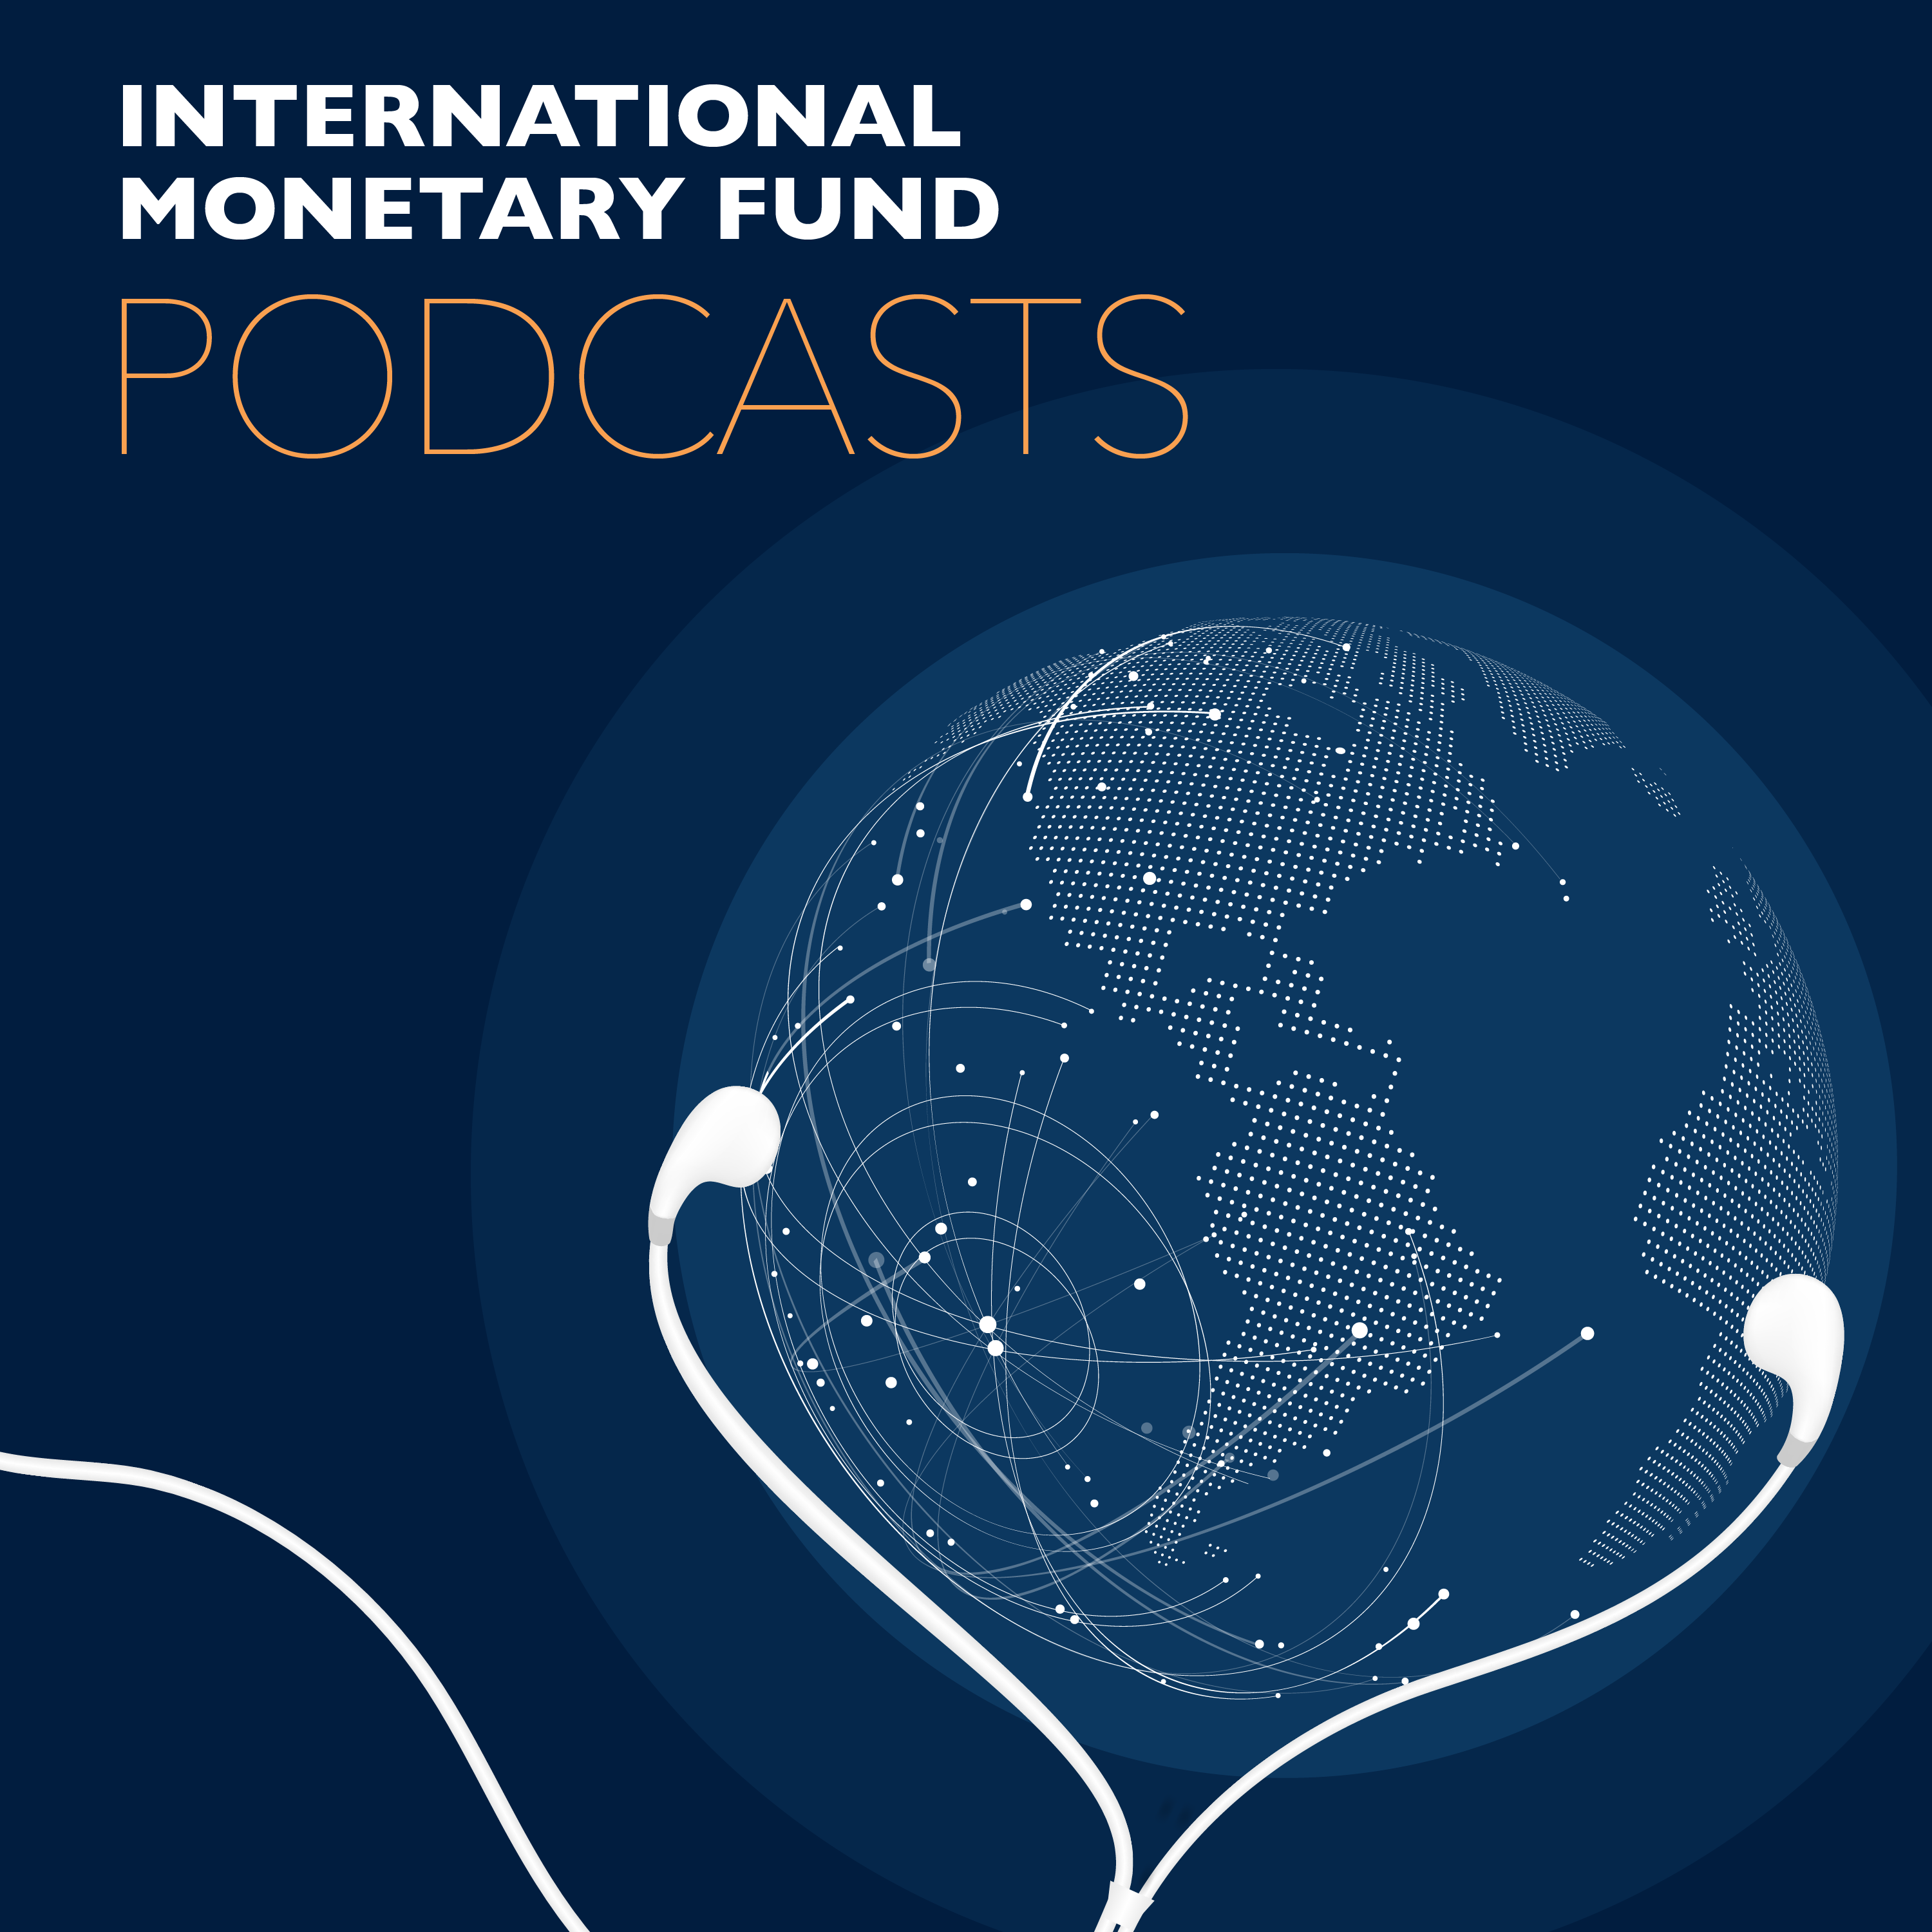
Transcript of IMF podcast:
Fiscal Policy Provides Lifelines to People, Economies
Vitor Gaspar:
What we're talking about is emergency lifelines to people, what people need to get in order to preserve their lives and their livelihoods.
Jacqueline Deslauriers:
Welcome to this podcast produced by the International Monetary Fund. I'm Jacqueline Deslauriers. The COVID-19 pandemic is a global crisis like no other that puts government spending on things like healthcare and employment, along with tax policy, at the heart of saving lives and the economic systems upon which people depend to survive. Vitor Gaspar is the head of the IMF's Fiscal Affairs Department, which twice a year puts together an in depth analysis on fiscal policy called the Fiscal Monitor. The latest issue released as the pandemic unfolds says countries need to do whatever it takes, because what governments do now will determine the speed and the strength of the eventual recovery.
Jacqueline Deslauriers:
So Vitor, what is your advice for countries to contain this pandemic?
Vitor Gaspar:
So the first is to recognize that a pandemic is a global phenomenon. It is a health emergency, it's not a traditional economic or financial crisis. Clearly countries around the world must be prepared to work together and they must be prepared to do whatever it takes to beat this health emergency. The public finance principles are very, very clear. The first priority is to enable the health system. Secondly, it is necessary to protect people and firms adversely affected by the health emergency and the containment measures of social distancing, which are necessary to tackle it. And after the pandemic is finally in the past, we have the third, which is engage in coordinated fiscal stimulus, but taking into account the different characteristics of different countries in particular their financing ability.
Vitor Gaspar:
But let me come back. Sometimes it is said that in a emergency like this one, countries should prepare to do whatever it takes, and I think that's absolutely right. But when you have to do whatever it takes, and you must do it fast because the situation is fast evolving and things have to be put under control, it is crucial to keep a record. It is crucial to have transparent accounting. It is crucial to keep a systematic record and it's important to reinforce good governance principles and accountability requirements to make sure that everything is above board at the end. So, in a few words; do whatever it takes, but do keep the receipts.
Jacqueline Deslauriers:
I think many people will assume that advanced economies can afford to do that, but what about emerging market and low income countries? Can they afford to take your advice?
Vitor Gaspar:
So there are various dimensions to the answer to that question. We have looked carefully at the cooperation that international community engaged in as a response to the Ebola outbreak that affected three West African countries back in 2014 and 2015, and what we saw was a very effective support of the international community.
Vitor Gaspar:
For example, in the case of the International Monetary Fund, it was in that context that the CCRT that provides debt relief to countries affected by catastrophes and other natural phenomena, it was in that context that the CCRT was created and endowed. And so there are many examples of the willingness of the international community to work together in the context of past health crisis, and that willingness to act together is crucial now and it's crucial to provide support to countries that are less well endowed with resources and health capacity in particular. It's not only financial resources which are necessary, human resources and medical equipment are important as well. Countries respond in accordance with the three dimensions that I outline and all countries will be doing some combination of this various principles. But the way they do it is very different and it has to be adapted to their own national characteristics, and we have many examples of innovative and I would even say creative use of policy instruments in this context. For example, in Bangladesh the government is increasing benefits under the existing cash transfer program and it's decreasing the prices of subsidized food under the voucher program. And in Bangladesh they're also planning to pay the wages of selected factory workers that have been affected by the pandemic.
Vitor Gaspar:
There are many countries around the world that are using innovative technologies to help contain the virus. For example, in Kenya, the authorities have negotiated a few waivers for the use of the payment systems platform M-Pesa for small person to person transactions and that allows them to take action in the direction of social distancing and remote transactions, which are cashless in which people can verify the validity of the transaction simply by looking at their mobile phones.
Vitor Gaspar:
In the state of Uttar Pradesh in India, the government is providing compensation to poor workers that work in many cases in the informal sector of the economy and the transfers are targeted directly to their bank accounts. And in Rwanda, again having to do with the challenge of how to reach informal workers, the authorities are organizing food distribution in Kigali and families dependent on informal workers are identified through community-based targeting. The reliance on communities in Rwanda is a very important characteristic of their policy design. So as you can see, the challenges are particularly strong, but the willingness and ability of the authorities to respond is very strong as well.
Jacqueline Deslauriers:
Vitor, you raise an interesting point on the question of targeted measures. Do you mean helping those who need it the most? What does targeting look like in practice?
Vitor Gaspar:
So, in general what we would say is that the crucial criteria is to protect people and firms that have been affected adversely by the crisis and that in the case of firms would otherwise have been viable. In the case of people, it's literally providing a replacement income in case they were hit adversely by the shock in order to avoid avoidable hardship associated with this event. In the case of firms, we want to try to preserve wages and employment and the idea is to maintain human capital to maintain productive capacity so that we have those precious assets in place when the economy is ready to run again.
Jacqueline Deslauriers:
Since you mentioned governments being ready to move on, I think the question on everyone's minds, even as we're in the grips of this pandemic, is once this is all over, how should governments sweep up, for lack of a better term, and move on?
Vitor Gaspar:
That's an excellent question. So when we are in a crisis it's very important to look ahead and see how the crisis can be overcome. How can we best recover after the crisis? And the point here is, first of all, as I already said, it's very important to take measures during the crisis so as to preserve human capital, to preserve productive capacity so that the economy is in the best possible shape to recover fast once the pandemic is passed. But in order to have the economy jump-starting at that point, it's very important to engage in stimulus policies, in particular in fiscal stimulus, that should be coordinated so as to make the economy recover as fast as it possibly can at that particular point in time.
Vitor Gaspar:
However, while being coordinated, the fiscal stimulus should be differentiated because countries are very different. The crisis will have hit countries in a completely different way and countries have very different financing abilities for example.
Jacqueline Deslauriers:
Since you bring up human capital, millions of people have already lost their jobs and are worried about very basic things; how to pay the rent, how, in some countries, to pay for medical care if they need it. How is tax policy and spending going to impact them? Why should they care about these things when they're struggling with the day to day right now?
Vitor Gaspar:
Human capital is a concept which is useful for economists and gives us a good grasp of what is necessary for the economy to be in a position to restart as strongly as it possibly can, but that's not the point which is most important as an answer to your question. Your question is about people and that's why I like to emphasize that what we're talking about is emergency lifelines to people, what people need to get in order to preserve their lives and their livelihoods.
Vitor Gaspar:
In the case of the example of the lady who lost her job and doesn't know how she is going to make ends meet for herself and her family in the next weeks, in the next months, getting unemployment benefits from the government, getting perhaps cash transfers is precisely what is going to make sure that she and her family face this exceptional times with minimum hardship, that they get the support and the protection they deserve and that when the economy starts again, she's in a very good position to get a job, to get a good job, to get perhaps an even better job than she had before the pandemic hit the world economy.
Jacqueline Deslauriers:
Thank you so much, Vitor.
Vitor Gaspar:
Thank you, Jacqueline.
Jacqueline Deslauriers:
Vitor Gaspar is the head of the IMS Fiscal Affairs Department, and you can read more details about the response to the crisis in the new issue of the Fiscal Monitor. And if you like what you're hearing, please subscribe to IMF podcasts wherever you get your podcasts. Thank you for listening.

