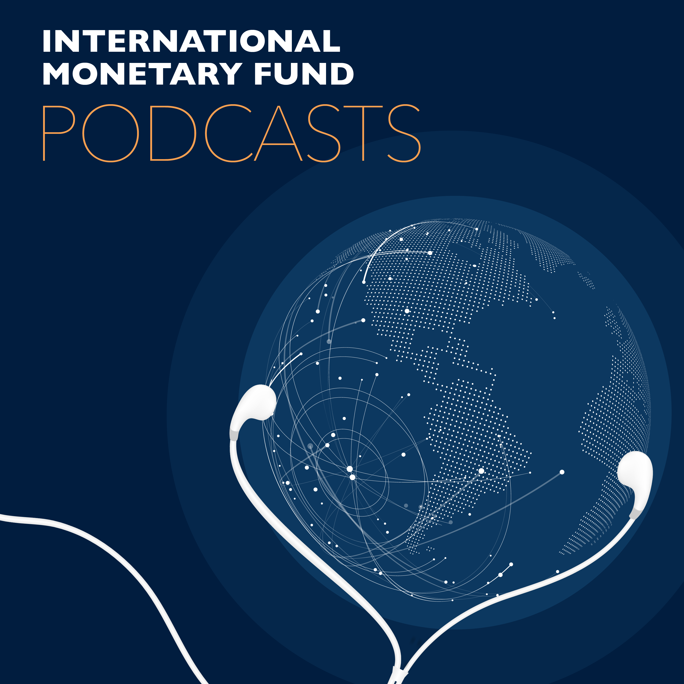
Transcript of IMF podcast:
Afsaneh Beschloss: Green Bonds for a Greener Future
Afsaneh Beschloss:
Bonds are debt instruments that raise money from markets for a variety of users.
Bruce Edwards:
Today, we look at bonds and their increasing role in fighting climate change.
Afsaneh Beschloss:
And what they do is these bonds range in structure, they're stipulated not just as interest in term, but also in terms of specific revenue streams or asset-based collateral. And as we get more projects that are investing in solar, in geothermal, in hydrogen, you will see the size of this market grow.
Afsaneh Beschloss:
My name is Afsaneh Mashayekhi Beschlos. I'm the founder and chief executive officer of the RockCreek Group.
Bruce Edwards:
Welcome to this podcast produced by the International Monetary Fund. I'm Bruce Edwards. Bonds have been helping corporations and governments finance infrastructure and large scale projects for hundreds of years. But the last decade has seen a shift in the bond market, largely driven by increasing environmental awareness.
Bruce Edwards:
Afsaneh Mashayekhi Beschlos says, global investment firms like RockCreek are seeing a growing demand for climate related investments in the form of green bonds. She says in the first half of 2019 alone, new certified green bond issues topped $100 billion globally.
Bruce Edwards:
Before founding RockCreek, Beschloss was treasurer and chief investment officer of The World Bank. Her recent article on a greener future for finance is published in the December 2019 edition of Finance and Development Magazine.
Bruce Edwards:
So, what is a green bond and how does that fit into a sustainable finance?

Afsaneh Beschloss:
What green bonds do is they add an extra level of complexity to regular bonds in the sense that they explicitly ring-fence use of proceeds towards green sustainable uses.
Bruce Edwards:
What would you consider a green or sustainable use?
Afsaneh Beschloss:
A green or sustainable use, for example, can be a bond that where the proceeds will get used for increasing energy efficiency in a building, in a city. It could be a bond that allows its proceeds to be used for installation of solar facilities or wind power.
Afsaneh Beschloss:
So, there are a variety of uses that I would personally consider, but also the market base in general I would consider as legitimate users of a green bond.
Afsaneh Beschloss:
There are now also a variation on the theme you're hearing about blue bonds, you're hearing about humanitarian bonds very specifically related to let's say related to things like marine life or oceans in the case of blue bonds.
Bruce Edwards:
Who decides whether or not a bond is actually green or sustainable? What is the process of determining that criteria?
Afsaneh Beschloss:
After the first green bond was issued by my friends at The World Bank in 2008, there was not initially like a group that would vet them. But over the last decade quite a few number of institutions have been created to vet them and to say whether they are green or not green.
Afsaneh Beschloss:
The most used institutions are ICMA. ICMA stands for International Capital Markets Association that was founded in 1969 to help guide the emerging euro bond market. It has now gradually expanded its scope to include a set of green loan and green bond principles since 2014.
Afsaneh Beschloss:
There is also CBI and then there are other firms, such as Cicero and Sustain Analytics and many others who have come into the marketplace. So they each have different methodology. In addition to all of the above, for example, the European Commission, the EU also has its own standards.
Afsaneh Beschloss:
Now, I think the attention that green bonds have got is really excellent to have all these bodies look at whether these bonds are getting used in the right way for the right users. Some people would also say there is maybe too excessive attention to these and I think that's a whole other interesting conversation.
Bruce Edwards:
So it's like a trend. So do you worry that this may well only be a trend?
Afsaneh Beschloss:
I think that issuing green bonds is actually not really a trend. I think it's something that is here to stay. Maybe out of the hundred trillion plus bond market close to just under one trillion so far has been issued in terms of green bonds.
Afsaneh Beschloss:
The numbers are expanding very fast though. For example, while in the first decade you had close to just over 500 billion issued. In 2020 at Rock Creek we estimate maybe over 400 billion just in one year to get issued. So I think it's not really a trend.
Afsaneh Beschloss:
I think it is something to stay. I think it's something that will expand and as there are more projects that one can earmark as green, then there will be even more green bonds that will get issued.
Afsaneh Beschloss:
In addition to that, when you look at the demand for these bonds is often far oversubscribed.
Bruce Edwards:
What prompted The World Bank to start issuing green bonds?
Afsaneh Beschloss:
What prompted my colleague Ken Lay who was then treasurer and is now at Rock Creek working together with me is very interesting. It was very demand oriented. A group of, for example, a Scandinavian pension plans approached the bank.
Afsaneh Beschloss:
The bank had been thinking about this, but they came in and said they're really interested in finding bonds to invest in hat would also be related to financing green projects.
Afsaneh Beschloss:
As you know, the Scandinavians have been sort of ahead of others in terms of using clean energy. Be that solar, wind, geothermal and now hydrogen even. So they have been ahead and they came as users and buyers of bonds.
Afsaneh Beschloss:
Were having these conversations and what happened at The World Bank Treasury is that as they always do, they went and talked to other people who buy bonds and they did research in the marketplace and tried to come up with a bond that would be true to its word and that's how the first bond I think got issued.
Bruce Edwards:
So there are some sectors that most people would not necessarily consider as being clean or sustainable, but do have a role in making the transition from brown to green. You mentioned this in Finance and Development Magazine. You mentioned the sector is being steel and concrete.
Afsaneh Beschloss:
Yes.
Bruce Edwards:
What is the predicament there?
Afsaneh Beschloss:
That's a really interesting question because steel and cement for example, use more than 15 to 17% of total energy. And in terms of emissions of CO2, they're really very carbon-heavy. The technology of producing them is pretty old technology.
Afsaneh Beschloss:
Now, as we speak, there's a lot of new technology that is coming into play, but it is like five to seven times more expensive. So it's not really yet technology that can replace cement and can replace-
Bruce Edwards:
It's not feasible.
Afsaneh Beschloss:
Exactly. At this moment it's not. But if you look at some of the R&D that's getting done, there's a lot of R&D that's going towards these sectors. Now in the old days they were very big coal energy users, cement in particular.
Afsaneh Beschloss:
I think what you're seeing now is that particular where natural gas is available as a transitional fuel, they're moving towards use of more relatively cleaner fuels. So there is a movement where you can start using cleaner existing sources of energy and renewable sources of energy to produce them.
Afsaneh Beschloss:
But the big change in terms of CO2 emissions will be when the R&D really comes into play.
Bruce Edwards:
So at the moment though steel and cement are included in some of these green bonds.
Afsaneh Beschloss:
Some of them are. Again, we have to be really careful because there is a funny term called greenwashing that is a very common term being used where even in China so-called clean coal technologies that they are using green bonds for. Those would really not pass muster, for example, in the European commission, I'm sure and they may not truly be green. It's a way of packaging.
Afsaneh Beschloss:
We should separate those from places where you're going from coal to a transitional fuel to renewables where there truly is, even if the end product is cement, the energy use is truly cleaner. So it is reducing CO2 emission. So I would separate those from where people are marketing green bonds but truly not using them for a green cause or reason.
Bruce Edwards:
Are the rates of return lower for green bonds than they are for the traditional bonds?
Afsaneh Beschloss:
Again, here at RockCreek we've done some research on this and our research shows that they are generally not lower. As I mentioned, the size of the market is still quite small and there's so much research you can do on the issuance. It's been just over 10 years of issuance and just under a trillion.
Afsaneh Beschloss:
So, the amount of research you can do while limited is showing that in fact these bonds have performed pretty close to other bonds of their own maturity or vintage. So, I would say that they are competitive and if anything, because again they have been oversubscribed, there is more demand than supply right now.
Bruce Edwards:
So making a business case for investing in bonds that where the risks and the returns aren't necessarily all that clear at this point you don't see a problem making that business case?
Afsaneh Beschloss:
Well I actually see it in a very different way in the sense that as we all know there is huge risks because of climate change too many industries, many companies. They have now realized whether you look at shell, which as you know, predominantly traditional energy company and chemical company.
Afsaneh Beschloss:
Even those kinds of companies are realizing that they need to morph into renewable energy in a big way if they want to survive. You look at many energy companies that see their assets becoming stranded assets, meaning people don't want to buy them.
Afsaneh Beschloss:
So if anything, I think the movement that we see today among investors and issuers is towards green bonds but also towards projects that are oriented towards renewable energy.
Afsaneh Beschloss:
So, if anything, I think the size of this markets will grow and investors as they get more and more sophisticated will be interested in investing in them as great investments.
Bruce Edwards:
Until you mentioned earlier the scale of the green bond market is fairly, I mean it's fairly small at this point, but growing.
Afsaneh Beschloss:
Growing really fast.
Bruce Edwards:
What would it take to attract more investment in sustainable finance?
Afsaneh Beschloss:
I think as we get more projects that are investing in energy efficiency as the more projects investing in solar power in geothermal, in hydrogen and other forms of clean energy as buildings and cities move towards cleaner technology and as demand for these kinds of, let's say certified buildings goes up, then what you see is that there will be more projects that these bonds can support.
Afsaneh Beschloss:
On the other side as investors are looking to invest in them, I think you will see the size of this market grow. In fact, in the last 12 months, I think the market might have grown as much as 25%.
Bruce Edwards:
Wow, that's significant. But are there any aspects of regulation or the way that these bonds are regulated that they could perhaps gain confidence of more investors?
Afsaneh Beschloss:
I think there's sort of the two extremes that is right now affecting the greater growth of this area. One is worried about greenwashing, so are these bonds really being used in an inappropriate way.
Create new speaker:
The other extreme is getting so involved in minutia and detailed measurement of did the year two emissions go up by this much or this much versus looking at the right direction, which is positively reducing carbon emissions.
Create new speaker:
What happens is that you have the two ends of the spectrum and those two ends of extremes can slow down the development more so than regulation in this case.
Bruce Edwards:
Are you optimistic? Are you fairly optimistic that this green bond market will grow?
Afsaneh Beschloss:
Absolutely. I'm very optimistic that this market will be continuing to outgrow traditional bond markets as in terms of the rate of growth.
Bruce Edwards:
Thank you very much.
Afsaneh Beschloss:
Thank you.
Bruce Edwards:
Afsaneh Mashayekhi Beschloss is the founder and CEO of the RockCreek Group. Her article, A Green Future for Finance, is published in the December 2019 edition of Finance and Development Magazine.
Bruce Edwards:
You can read the article online at imf.org/fandd or download the Finance and Development app to read it on your mobile device. Look for other IMF podcasts wherever you get your podcasts. Subscribe if you like what you're hearing, and follow us on Twitter @imf_podcast. Thanks for listening.

