BIOGRAPHY OF PANELISTS
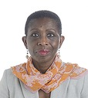 | Antoinette M. Sayeh assumed office as Deputy Managing Director of the IMF on March 16, 2020. Ms. Sayeh has been a Distinguished Visiting Fellow at the Center for Global Development (CGD) since November 2016 and was Co-Chair for the recently concluded 19th Replenishment of the International Development Association (IDA19), the World Bank’s Fund for the poorest. She previously oversaw and significantly enhanced the IMF’s engagement with its sub-Saharan African members as Director of the African Department between July 2008 and August 2016. As Minister of Finance in post-conflict Liberia (January 2006 through June 2008), she led the country through the clearance of its long-standing multilateral debt arrears, the HIPC Decision Point, the Paris Club, and its first Poverty Reduction Strategy, significantly strengthening its public finances and championing public financial management reform. Before joining President Ellen Johnson Sirleaf’s Cabinet, Ms. Sayeh worked for the World Bank for 17 years, including as Country Director for Benin, Niger, and Togo; Senior Country Economist for Pakistan and Afghanistan, as well as an Advisor in the Bank’s Operations Policy Vice Presidency and as Assistant to its principal Managing Director. Before joining the Bank, Ms. Sayeh worked in economic advisory positions in Liberia’s Ministries of Finance and Planning.  Ms. Sayeh graduated with a bachelor’s degree with honors in economics from Swarthmore College and a PhD in International Economic Relations from the Fletcher School at Tufts University. While at CGD, Ms. Sayeh has also served on the Board of Managers of Swarthmore College; Board of Directors of the Ellen Johnson Sirleaf Presidential Center for Women and Development; and Board of Directors of Emerging Public Leaders.
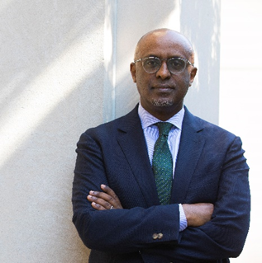 | Abebe Aemro Selassie is the Director of the African Department at the International Monetary Fund, a position he has held since 2016. In this capacity, Mr. Selassie oversees the IMF’s operations and engagement with 45 countries across sub-Saharan Africa, spanning the three main pillars of IMF work—policy advice, lending operations, and technical assistance. His responsibilities also include building strategic partnerships and dialogue with senior policymakers and institutions across the region.  Before taking up his current position, Mr. Selassie gained extensive experience in a wide-ranging 22-year career at the IMF. He held various senior positions, including Deputy Director in the African Department, Mission Chief for Portugal and South Africa, Division Chief of the African Department’s Regional Studies Division, and the IMF’s Senior Resident Representative in Uganda. Earlier in his career, he worked on the Fund’s lending programs with Turkey, Thailand, Romania and Estonia as well as being deeply involved in policy, operational review, and economic research work.  Before joining the IMF in 1994, he worked for the Government of Ethiopia and the Economist Intelligence Unit in London. Mr. Selassie is an Ethiopian national. He completed his graduate studies at the London School of Economics.
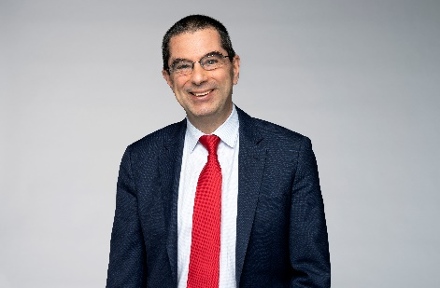 | Vitor Gaspar is Director of the Fiscal Affairs Department at the IMF. He joined in 2014. Before that, he was Portuguese Minister of State and Finance from 2011–13, and has held various positions in European and Portuguese institutions, including head of BEPA at the European Commission, director-general of research at the European Central Bank, director of Economic Studies and Statistics at the Central Bank of Portugal, and Director of Economic Studies at the Portuguese Ministry of Finance.  Mr. Gaspar holds a Ph.D. and a post-doctoral agregado in Economics from Universidade Nova de Lisboa; he graduated from Universidade Católica Portuguesa.
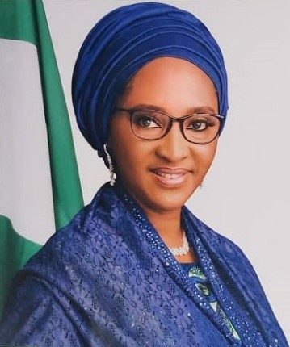 | Zainab Shamsuna Ahmed is Minister of Finance, Budget & National Planning of Nigeria since 2019. Prior to that she was Minister of Finance and Minister of State for Budget & National Planning. She has served as a member of the International Board of the Extractive Industries Transparency Initiative (EITI), and Co-Chair of the Open Governance Partnership (OGP). She has a B.Sc. Accounting from the Prestigious Ahmadu Bello University Zaria, Nigeria and studied for her MBA at the Ogun State University, Ago Iwoye, Nigeria. She is a fellow of the Association of National Accountants of Nigeria (ANAN), Institute of Company and Commercial Accountants (ICCA), Chartered Institute of Taxation (CITN) and the Nigerian Institute of Management (NIM).
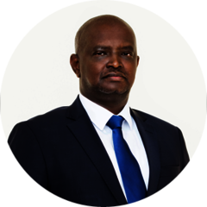 | Leonard Rugwabiza is the Economic Advisor to the Minister of Finance and Economic Planning and member of the Board of Directors at the National Bank of Rwanda. He also served as the Chief Economist, Ministry of Finance and Economic Planning since 2015, prior to that he was the director general for national planning and research at Rwanda's Ministry of Finance and Economic Planning, he spent two years as an economist with the African Development Bank. Earlier, he served in the strategic planning unit of the Ministry of Finance. He has been instrumental in shaping, strategizing and implementing Rwanda’s economic policies.
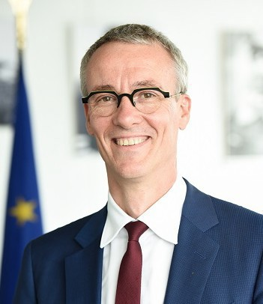 | Koen Doens is Director-General for International Partnerships at the European Commission. Before that, he held various positions, including Deputy Director General responsible for Africa, Asia, Middle East/Gulf, Pacific, Latin America and Caribbean in the Directorate General for International Cooperation and Development, Director for EU-Africa Relations, East and Southern Africa in the Directorate General for International Cooperation and Development, Head of the Spokespersons' Service. Prior to joining the European Commission, he was a diplomat in Syria, Iran, the Russian Federation.

